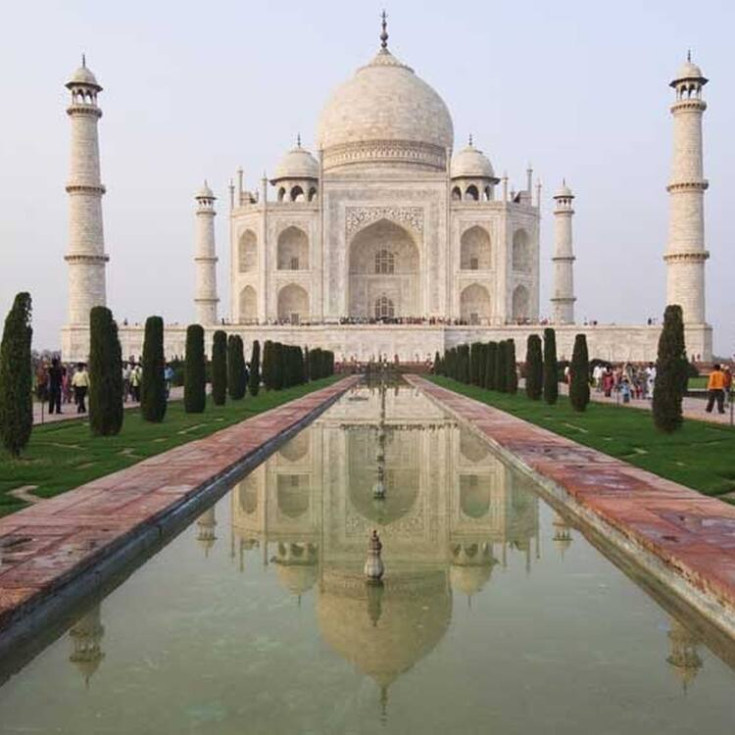**Taj Mahal**

The Taj Mahal: an ivory masterpiece that breathes eternal love and architectural grace along the banks of the Yamuna River in Agra, India.

**History**

Commissioned by Emperor Shah Jahan in the 17th century, the Taj Mahal stands as a testament to undying love, built in memory of his wife Mumtaz Mahal. Its construction spanned over two decades, culminating in 1653 as a majestic marvel of Mughal architecture in Agra, India.